**DIVISION USING 8086 PROCESSOR**

**AIM:** To write an assembly language program to implement division using 8086 processor.

**ALGORITHM:**

1. Load the dividend (the number to be divided) into the DX:AX register pair, with the higher 16 bits in DX and the lower 16 bits in AX.

2. Load the divisor (the number to divide by) into the BX register.

3. Use the DIV instruction to perform the division.

4. The quotient will be stored in the AX register, and the remainder will be stored in the DX register.

5. You can then access the quotient and remainder from the AX and DX registers, respectively, and use them as needed.

**PROGRAM:**

MOV AL, 4 ; AL = 04h

MOV BL, 2

DIV BL ; AX = 02h (02)

; print result in binary:

MOV bl, al

MOV cx, 8

print: MOV ah, 2 ; print function.

MOV dl, '0'

TEST bl, 10000000b ; test first bit.

JZ zero

MOV dl, '1'

zero: INT 21h

SHL bl, 1

LOOP print

; print binary suffix:

MOV dl, 'b'

INT 21h

; wait for any key press:

MOV ah, 0

INT 16h

RET

**OUTPUT:**

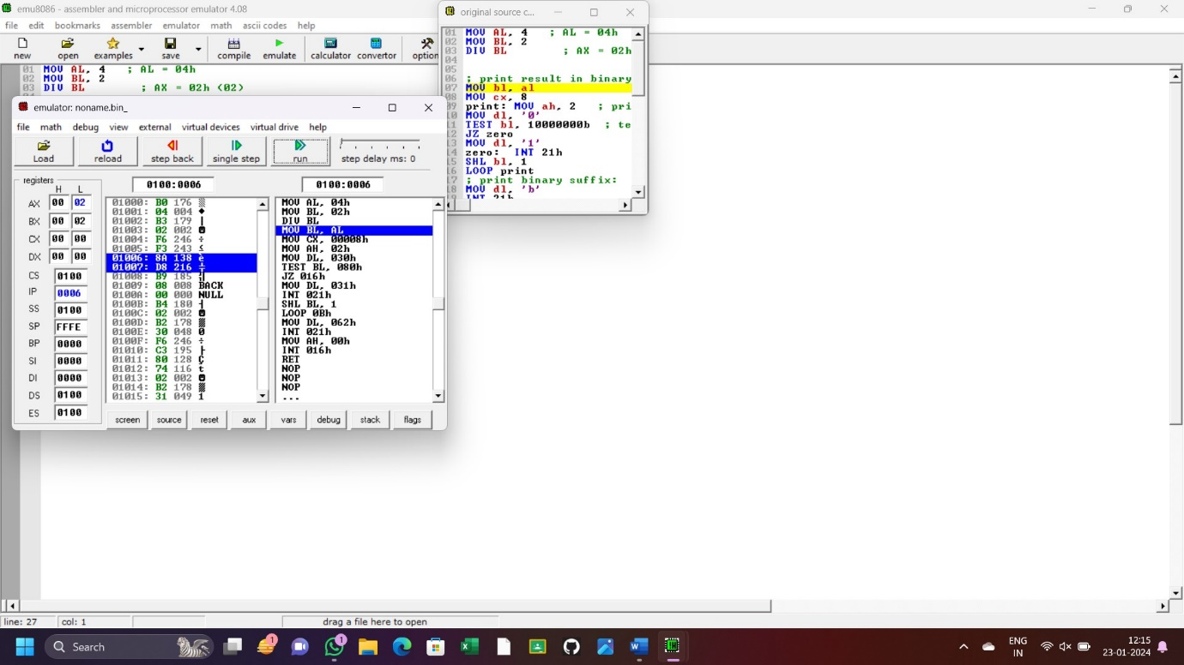

**RESULT:** Thus the program is implemented successfully using 8086 microprocessor